**Lab - Encrypting and Decrypting Data Using OpenSSL**

## Encrypting Messages with OpenSSL

### Encrypting a Text File

* + - 1. Log into CyberOPS Workstation VM.
      2. Open a terminal window.
      3. Because the text file to be encrypted is in the /home/analyst/lab.support.files/ directory, change to that directory:

[analyst@secOps ~]$ **cd ./lab.support.files/**

[analyst@secOps lab.support.files]$

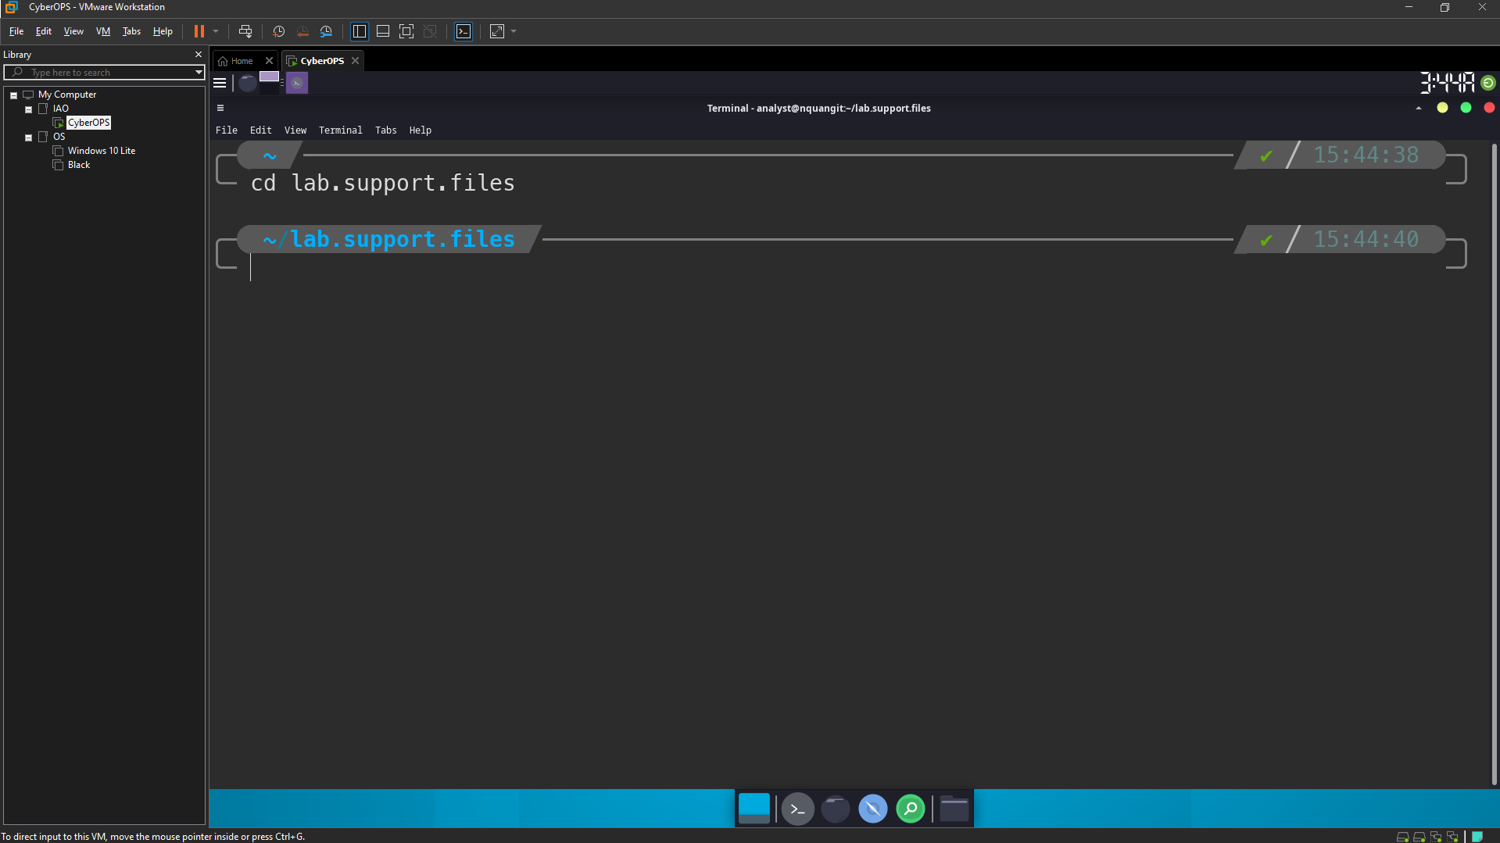

* + - 1. Type the command below to list the contents of the encrypted **letter_to_grandma.txt** text file on the screen:

[analyst@secOps lab.support.files]$ **cat letter_to_grandma.txt**

Hi Grandma,

I am writing this letter to thank you for the chocolate chip cookies you sent me. I got them this morning and I have already eaten half of the box! They are absolutely delicious!

I wish you all the best. Love,

Your cookie-eater grandchild.

[analyst@secOps lab.support.files]$

* + - 1. From the same terminal window, issue the command below to encrypt the text file. The command will use AES-256 to encrypt the text file and save the encrypted version as **message.enc**. OpenSSL will ask for a password and for password confirmation. Provide the password as requested and be sure to remember the password.

[analyst@secOps lab.support.files]$ **openssl aes-256-cbc -in letter_to_grandma.txt -out message.enc**

enter aes-256-cbc encryption password:

Verifying - enter aes-256-cbc encryption password:

[analyst@secOps lab.support.files]$

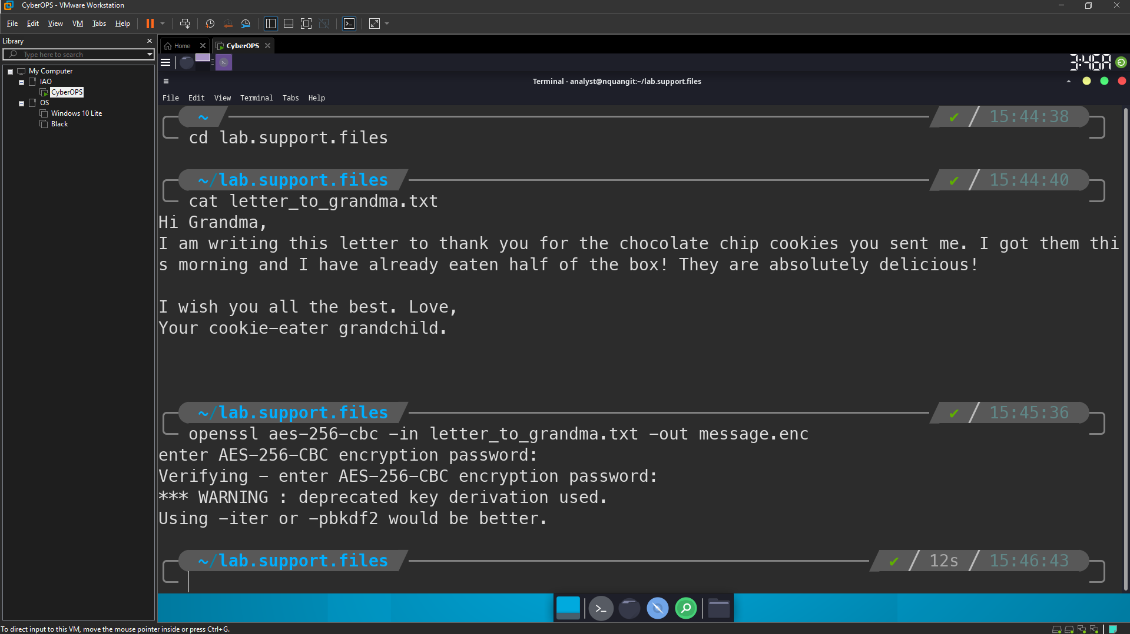

#### Question:

Document the password.

Password is: “quang”

* + - 1. When the process is finished, use the **cat** command again to display the contents of the **message.enc** file.

[analyst@secOps lab.support.files]$ **cat message.enc**

#### Question:

Did the contents of the **message.enc** file display correctly? What does it look like? Explain.

No, just have symbols displayed. OpenSSL generate a binary file.

* + - 1. To make the file readable, run the OpenSSL command again, but this time add the **-a** option. The **-a** option tells OpenSSL to encode the encrypted message using a different encoding method of Base64 before storing the results in a file.

**Note**: Base64 is a group of similar binary-to-text encoding schemes used to represent binary data in an ASCII string format.

[analyst@secOps lab.support.files]$ **openssl aes-256-cbc -a -in letter_to_grandma.txt -out message.enc**

enter aes-256-cbc encryption password:

Verifying - enter aes-256-cbc encryption password:

* + - 1. Once again, use the **cat** command to display the contents of the, now re-generated, **message.enc** file:

**Note**: The contents of **message.enc** will vary.

[analyst@secOps lab.support.files]$ **cat message.enc**

U2FsdGVkX19ApWyrn8RD5zNp0RPCuMGZ98wDc26u/vmj1zyDXobGQhm/dDRZasG7

rfnth5Q8NHValEw8vipKGM66dNFyyr9/hJUzCoqhFpRHgNn+Xs5+TOtz/QCPN1bi

08LGTSzOpfkg76XDCk8uPy1hl/+Ng92sM5rgMzLXfEXtaYe5UgwOD42U/U6q73pj

a1ksQrTWsv5mtN7y6mh02Wobo3A1ooHrM7niOwK1a3YKrSp+ZhYzVTrtksWDl6Ci

XMufkv+FOGn+SoEEuh7l4fk0LIPEfGsExVFB4TGdTiZQApRw74rTAZaE/dopaJn0

sJmR3+3C+dmgzZIKEHWsJ2pgLvj2Sme79J/XxwQVNpw=

[analyst@secOps lab.support.files]$

#### Questions:

Is **message.enc** displayed correctly now? Explain.

Can you think of a benefit of having **message.enc** Base64-encoded?

The **message.enc** can be display normally. Because the binary data has been encoded with base64. So it is readable.

Benefit: If we encrypt the data in normal way without base64 encode, it is so hard for user to copy/send it to another. With base64 user can copy that data and send it to other by email, …

## Decrypting Messages with OpenSSL

* + - 1. Use the command below to decrypt message.enc:

[analyst@secOps lab.support.files]$ **openssl aes-256-cbc –a -d -in message.enc -out decrypted_letter.txt**

* + - 1. OpenSSL will ask for the password used to encrypt the file. Enter the same password again.
      2. When OpenSSL finishes decrypting the **message.enc** file, it saves the decrypted message in a text file called **decrypted_letter.txt**. Use the **cat** display the contents of **decrypted_letter.txt**:

[analyst@secOps lab.support.files]$ **cat decrypted_letter.txt**

#### Questions:

Was the letter decrypted correctly?

Yes

The command used to decrypt also contains -a option. Can you explain?

Because the newest file “message.enc” was encoded with base64. So when we decrypt the data, we also must decode base64 data first to convert it into binary file before decrypt.